CENWP-OD-B 14 July 2024

MEMORANDUM FOR THE RECORD

SUBJECT: 24BON028 MFR WA Shore UMTJ RB2 Pacific Lamprey Mortality

On the morning of 14 July 2024, Project Biologists discovered one adult Pacific Lamprey mortality in Rest Box 1 of the Washington Shore Upstream Migrant Transportation Junction LPS (WA Shore UMTJ LPS RB2). The fish was measured, scanned for PIT tags, inspected, and returned to the river.

- Species – Pacific Lamprey (Entospehnus tridentatus)
- Origin – Unknown
- Length – 65.41cm
- Marks and tags – None
- Marks and Injuries found on carcass – Some bleeding from orifices, but no visible injuries
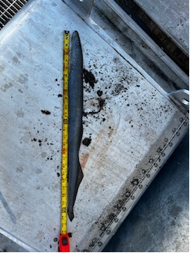
- Cause and Time of Death – Unknown
- Future and Preventative Measures – N/A

Sincerely,
Project Fisheries

